Nepal College of Information Technology
Balkumari Lalitpur
Assessment Exam Spring Semester 2008
Year: I Sem: II
Program: IT Time: 3hrs
FM: 100 PM: 50

Electronic Device
Attempt all questions.
1. a) For the zener diode voltage regulator circuit shown in figure 1, determine
i) minimum and maximum load current.
(ii) minimum and maximum power dissipated in the load 8
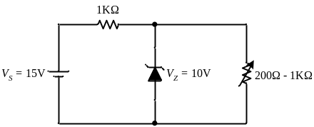Figure 1
b) What is a varactor diode? Derive expression for the transition capacitance of a reverse biased pn junction. 7
2. a) What do you mean by the reverse recovery period of a diode? Explain it with necessary circuit diagrams and various waveforms. 7
b) Explain the operation of an npn BJT. Why do we call a npn or a pnp construction a bipolar junction transistor? 8
3. a) Find the bias point for the Si transistor in the CB amplifier circuit shown in figure 2. 8
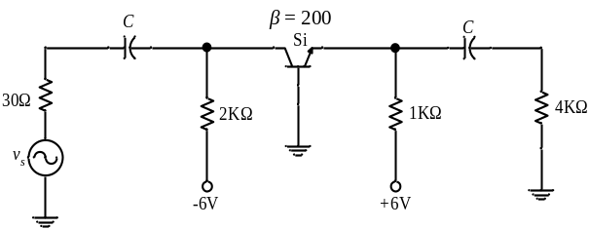Figur 2
b) Determine the stability factors S, S’ and S’’ for the self bias circuit. 8
4. a) For the amplifier circuit shown in figure 3, determine
i) rms load voltage, v_{L}.
ii) input resistances r_{in} and r_{in(stage)} as shown in figure. 7
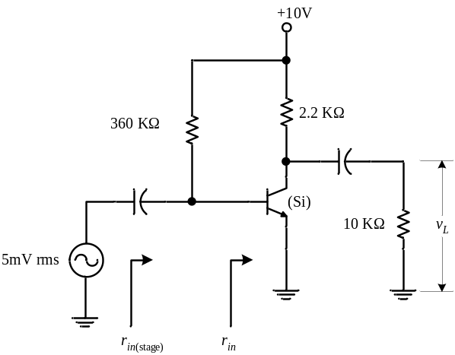Figure 3
b) For the CE amplifier circuit shown in figure 4, determine A_{i} r_{o} and r_{o(stage)}. Given the h-parameters for the transistor used are h_{ie} = 1.6KΩ, h_{fe} = 80, h_{re} = 2×10⁻⁴ and h_{oe} = 20μA/V.
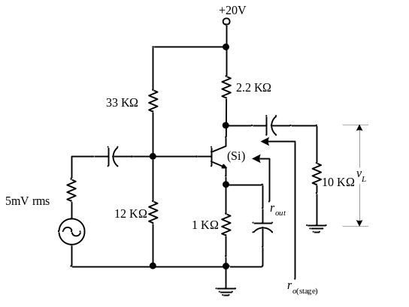Figure 4
5. a) Draw neat diagrams of drain and transfer characteristics of an N-channel JFET and explain the curves in detail. 7
b) The JFET in the amplifier circuit shown in Figure 5 has I_{DSS} = 12mA, V_{p} = -4V, and r_{d} = 100KΩ. Find the voltage gain for the amplifier circuit. 8
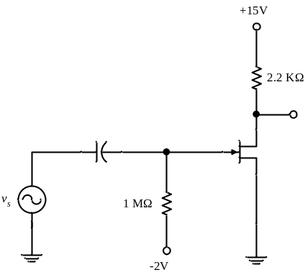Figure 5
6. a) Write down the differences between enhancement type and depletion type MOSFET. 8
b) A dual clipper circuit is shown in figure 6. For v_{s} = 10sin(2πft), determine the output voltage v_{o}(t). 7
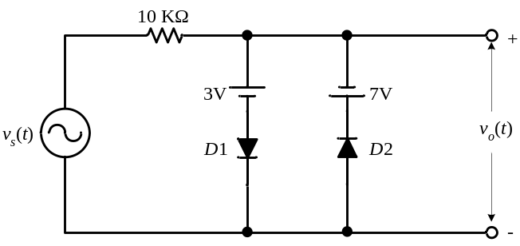Figure 6

7. Write short notes(Any Two) 5*2
i) Tunnel diode
ii) Punchthrough Breakdown
iii) High frequency T-model
iv) UJT

